[62. Unique Paths](https://leetcode.com/problems/unique-paths/)

Medium

14.6K

399

Companies

There is a robot on an m x n grid. The robot is initially located at the **top-left corner** (i.e., grid[0][0]). The robot tries to move to the **bottom-right corner** (i.e., grid[m - 1][n - 1]). The robot can only move either down or right at any point in time.

Given the two integers m and n, return *the number of possible unique paths that the robot can take to reach the bottom-right corner*.

The test cases are generated so that the answer will be less than or equal to 2 * 109.

**Example 1:**

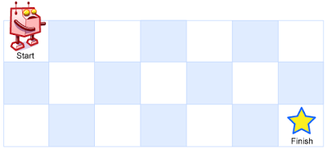

**Input:** m = 3, n = 7

**Output:** 28

**Example 2:**

**Input:** m = 3, n = 2

**Output:** 3

**Explanation:** From the top-left corner, there are a total of 3 ways to reach the bottom-right corner:

1. Right -> Down -> Down

2. Down -> Down -> Right

3. Down -> Right -> Down

**Constraints:**

* 1 <= m, n <= 100